Name: Micah Perkins, Krutarth Patel

EECE.2650 Logic Design

Assignment 5  
  
**Design of Arithmetic Logic Unit**

**Datapath Module**

**Data Path Table: Use this table to determine which signals go where for each instruction. You can then use this table to wire your datapath so that the muxes route the correct signals**

**The first instruction is filled out for you. A + B uses the full adder for addition (c0 = 0) the inputs to the full adder xi and yi get Ai and Bi respectively.**

|  |  |  |  |  |  |
| --- | --- | --- | --- | --- | --- |
| **OpCode** | **Instruction** | **xi** | **yi** | **c0** | **Output Selector** |
| 0 0 0 | Add A + B | Ai | Bi | 0 | Full Adder |
| 0 0 1 | Increment A | Ai | Const=0000 | 1 | Full Adder |
| 0 1 0 | Invert A | NOT(Ai) | Const=0000 | 0 | Invert A |
| 0 1 1 | Subtract B - A | NOT(Ai) | Bi | 1 | Full Adder |
| 1 0 0 | Decrement A | Ai | Const=1111 (-1) | 0 | Full Adder |
| 1 0 1 | A | B | Ai | Bi | 1 | OR |
| 1 1 0 | A & B | Ai | Bi | 0 | AND |
| 1 1 1 | Negative A | NOT(Ai) | Const=0000 | 1 | Full Adder |

**Completed Datapath:** 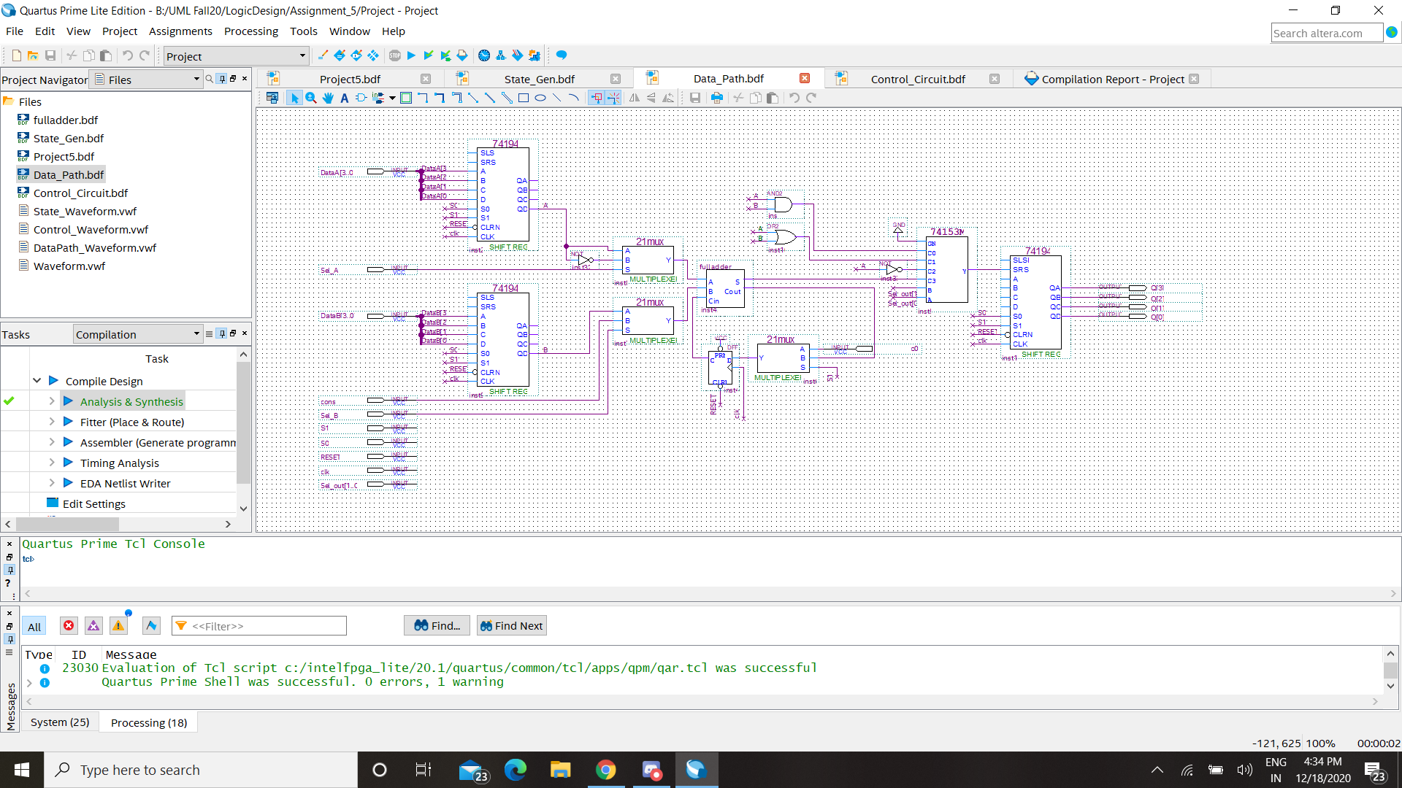

**State Diagram for the State Generator:**

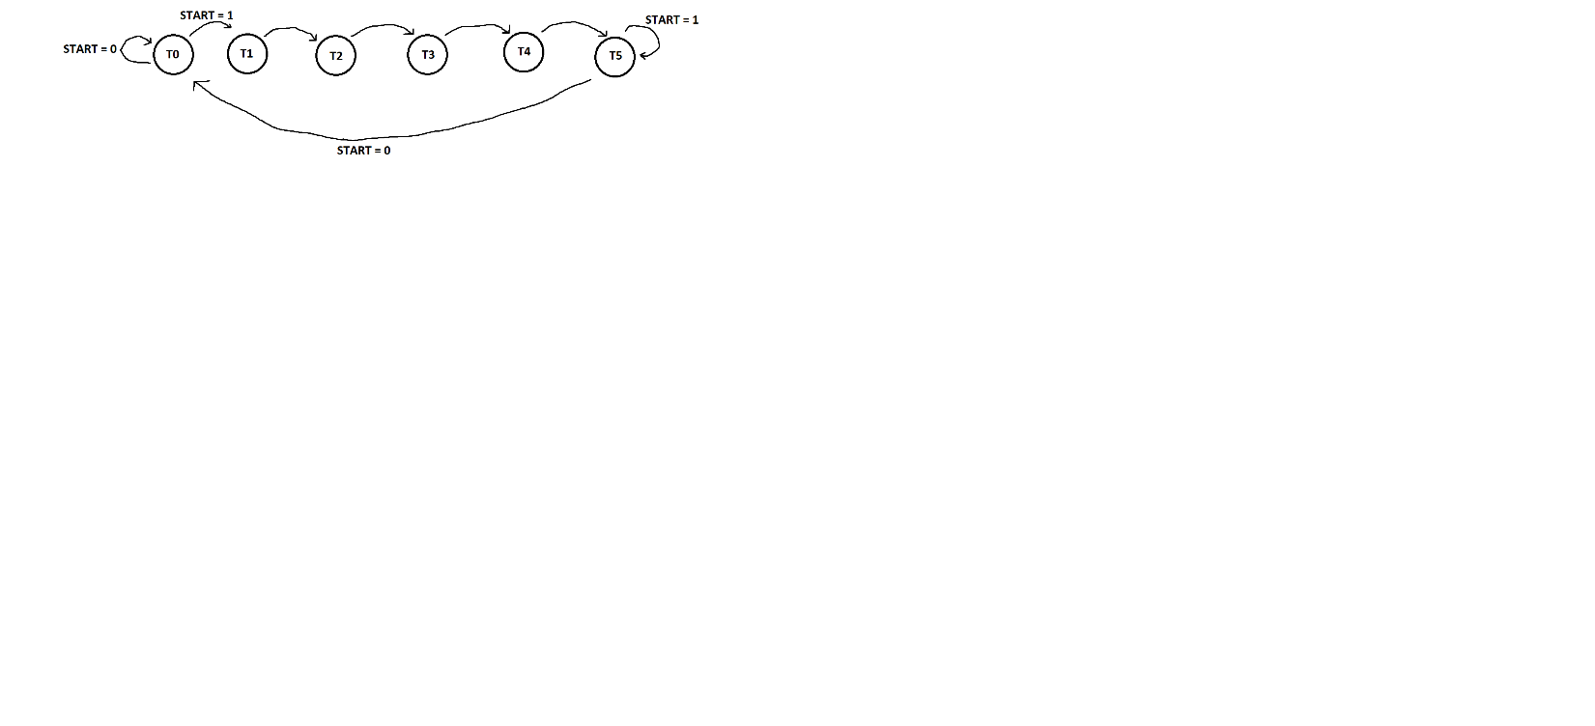 **Transition Table for the State Generator:**

|  |  |  |  |
| --- | --- | --- | --- |
| **Present State** | **START** | **Next State** | **s1 s0** |
| T0 | 0 | T0 | 0 0 |
| T0 | 1 | T1 | 11 |
| T1 | D | T2 | 01 |
| T2 | D | T3 | 01 |
| T3 | D | T4 | 01 |
| T4 | D | T5 | 01 |
| T5 | 0 | T0 | 00 |
| T5 | 1 | T5 | 00 |

**Using the table above, find the Next State Equations for T0-T5 and equations for s1 and s0:**

**T0+ = (T0 & NOT_START) OR (T5 & NOT_START)**

**T1+ = T0 & START**

**T2+ = T1**

**T3+ = T2**

**T4+ = T3**

**T5+ = T4 OR (T5 & START)  
S0 = NOT_(T5 OR (T0 & NOT_START))  
S1 = T0 & START**

**Block Diagram for state generator:**

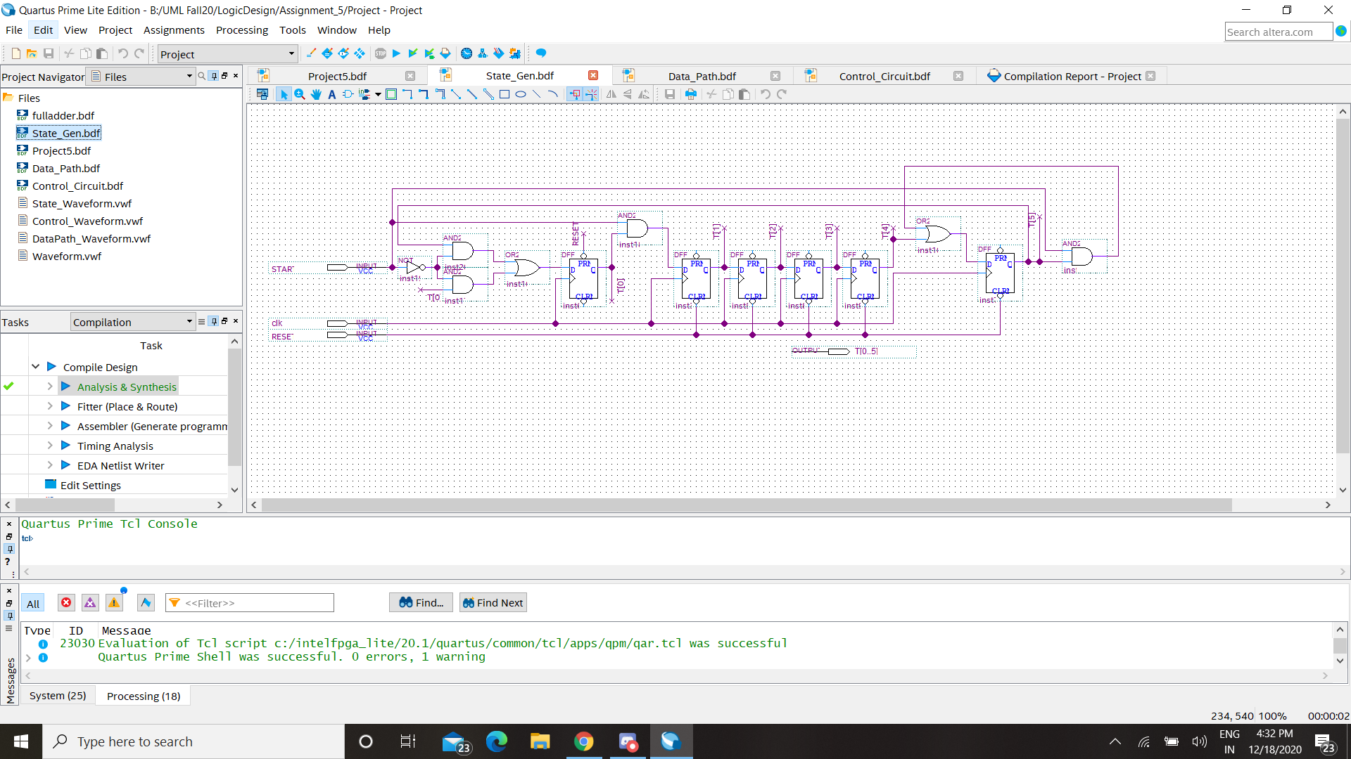

**Control Circuit Truth Table:**

|  |  |  |  |  |  |  |
| --- | --- | --- | --- | --- | --- | --- |
| **OpCode** | **Instruction** | **Sel_A** | **Sel_B** | **Sel_out[1..0]** | **c0** | **Const** |
| **0 0 0** | **Add A + B** | **1 (Ai)** | **1 (Bi)** | **11** | **0** | **0** |
| **0 0 1** | **Increment A** | **1** | **0 (Const)** | **11** | **1** | **0** |
| **0 1 0** | **Invert A** | **dc** | **dc** | **10** | **0 (dc)** | **0 (dc)** |
| **0 1 1** | **Subtract B - A** | **0 (Ai NOT)** | **1** | **11** | **1** | **0** |
| **1 0 0** | **Decrement A** | **1** | **0** | **11** | **0** | **1** |
| **1 0 1** | **A | B** | **Dc** | **Dc** | **01** | **1 (dc)** | **0 (dc)** |
| **1 1 0** | **A & B** | **Dc** | **Dc** | **00** | **0 (dc)** | **0 (dc)** |
| **1 1 1** | **Negative A** | **0** | **0** | **11** | **1** | **0** |

**Equations for each control signal: (You may choose to use a KMAP for each signal)** 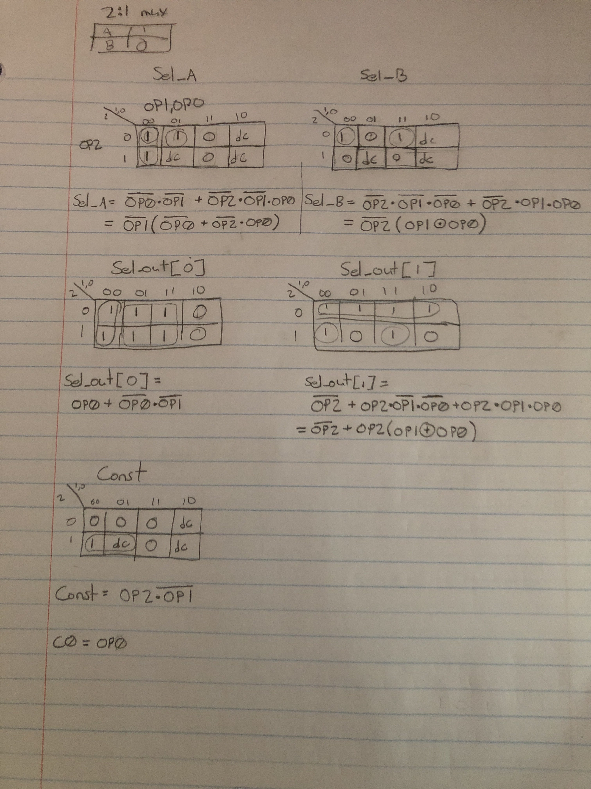

**Block Diagram for Control Circuit:** 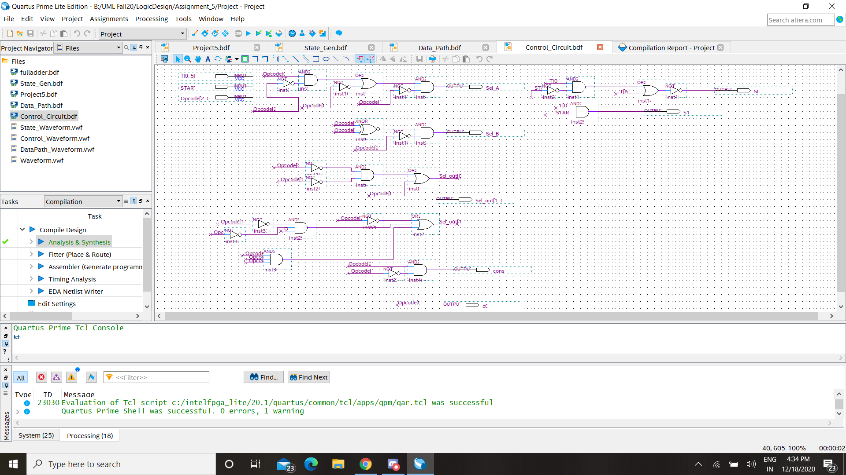

**Block Diagram for Completed Circuit:** 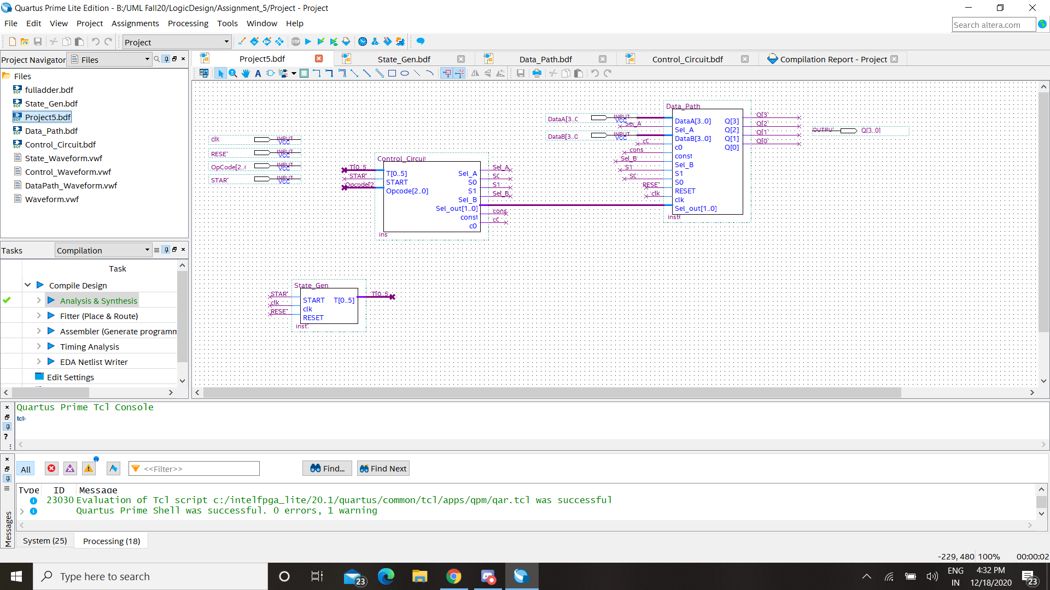

**Testing of ALU:**

Paste images showing each OpCode being performed successfully below. Be sure to label each image with the Opcode being used and its instruction.

**Example:**

Simulation for OpCode 000, A+B:

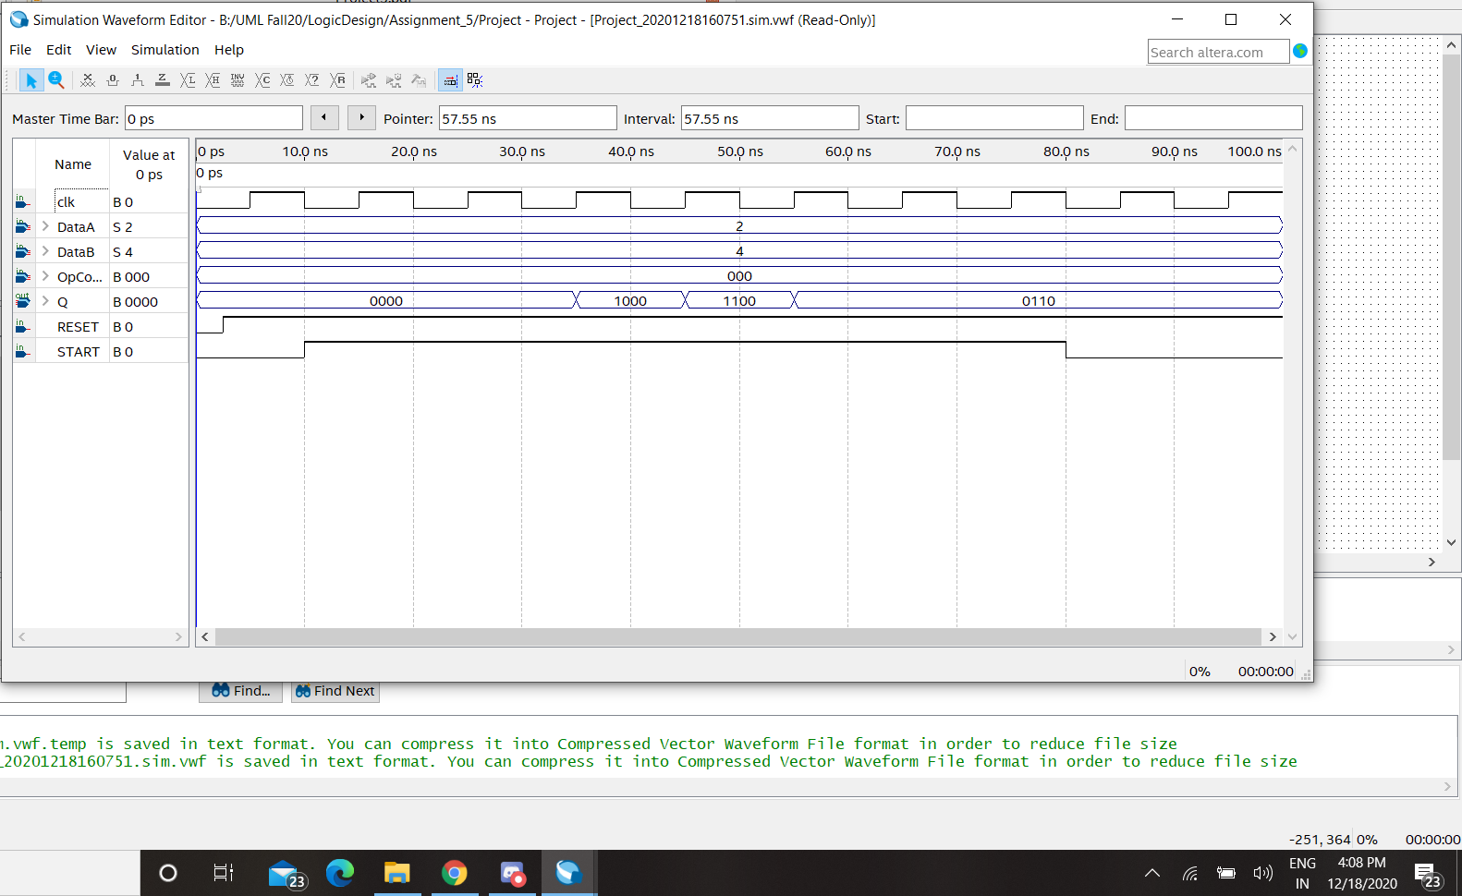

Simulation for OpCode 001, Increment A:

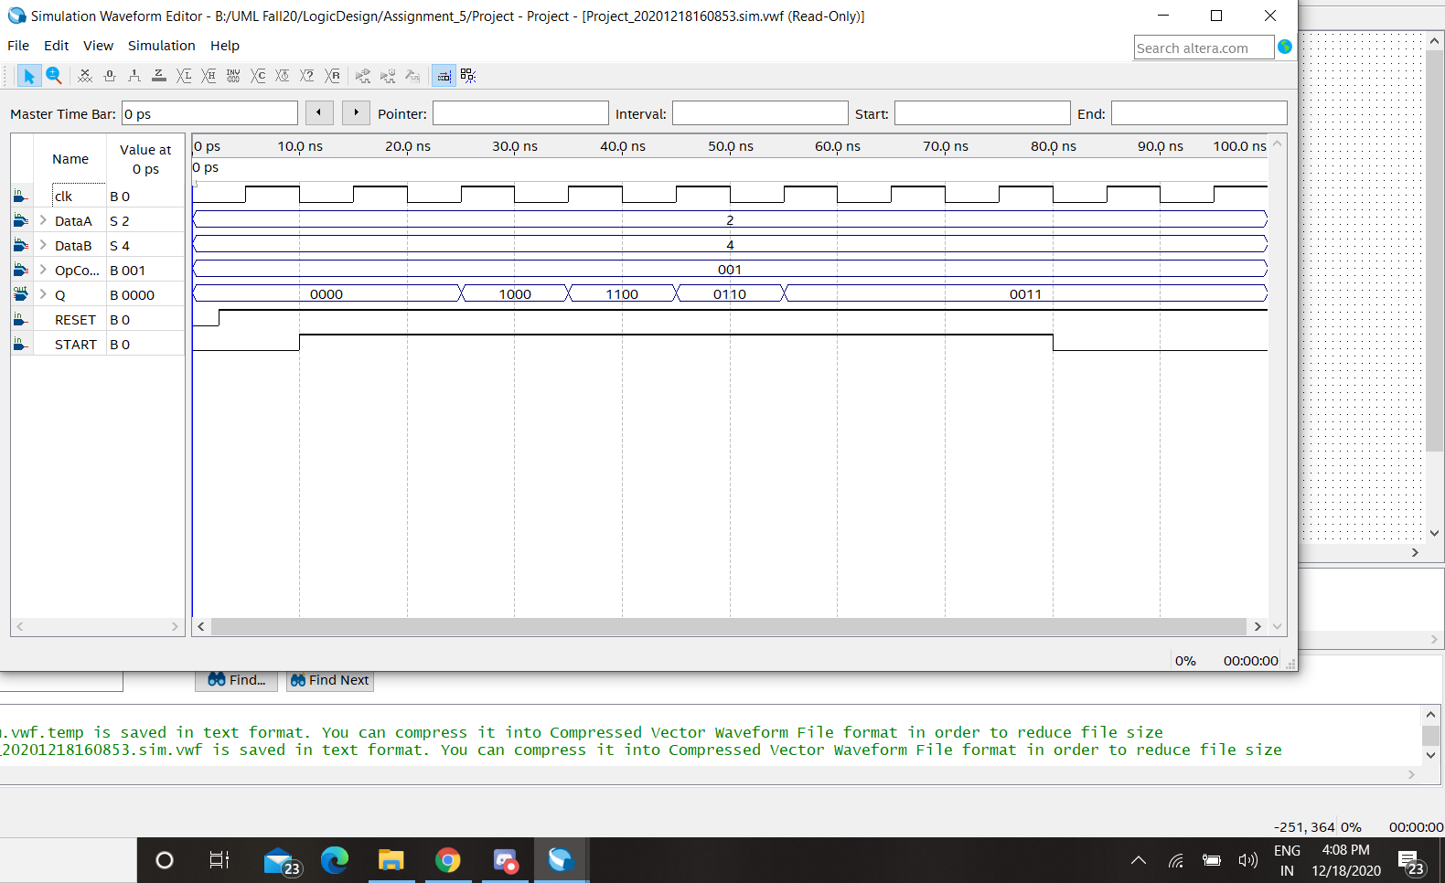

Simulation for OpCode 010, Invert A:

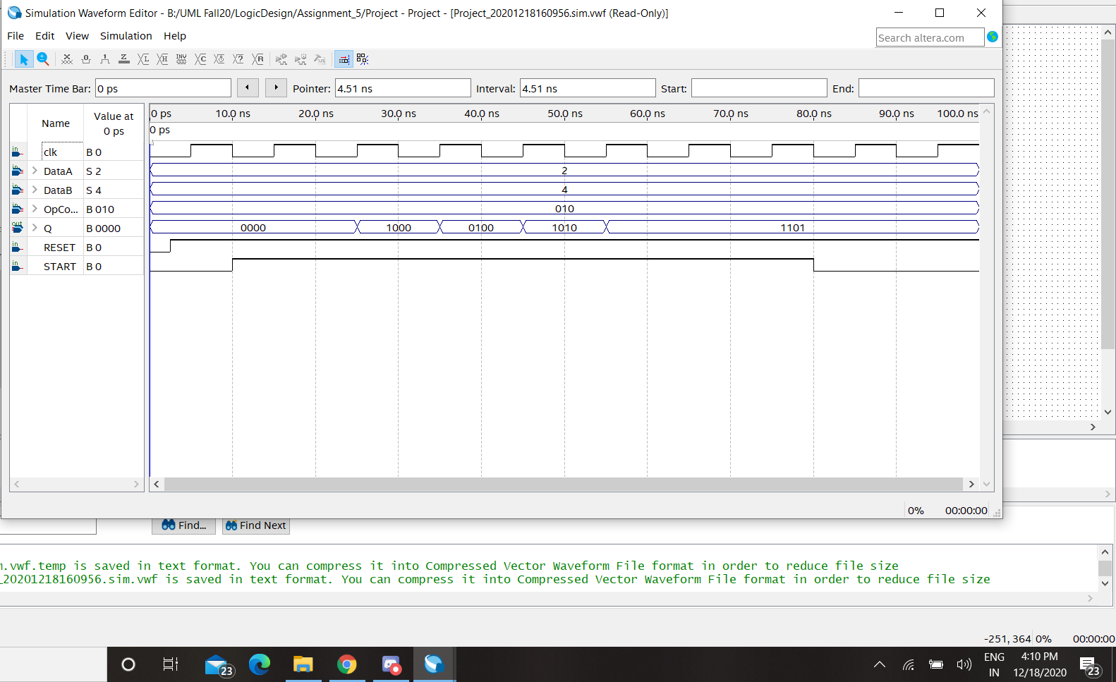

Simulation for OpCode 011, B-A:

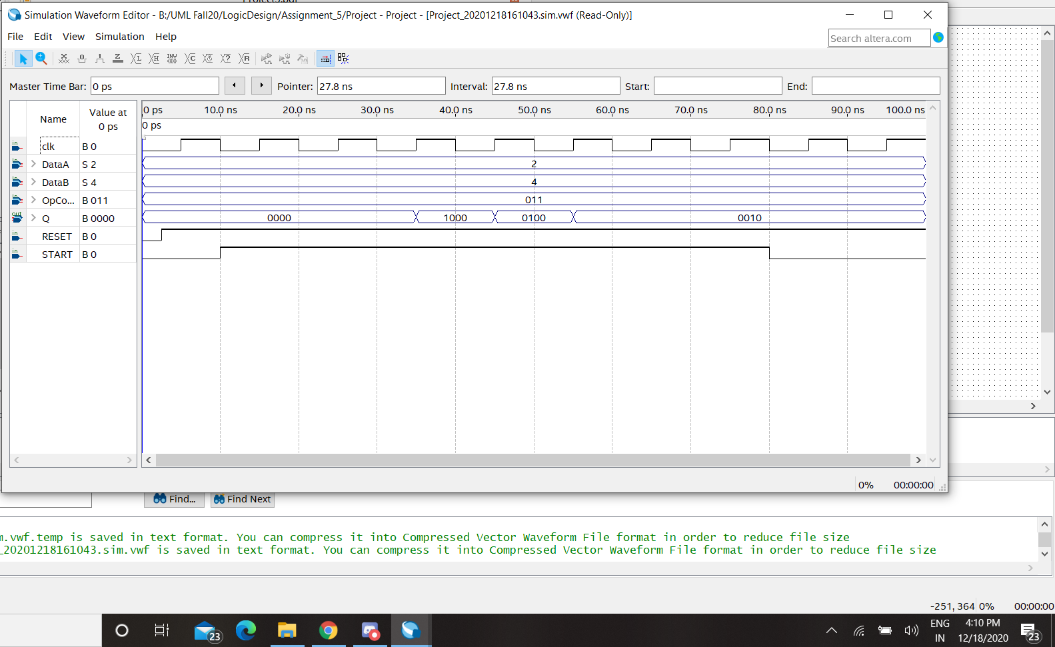

Simulation for OpCode 100, Decrement A:

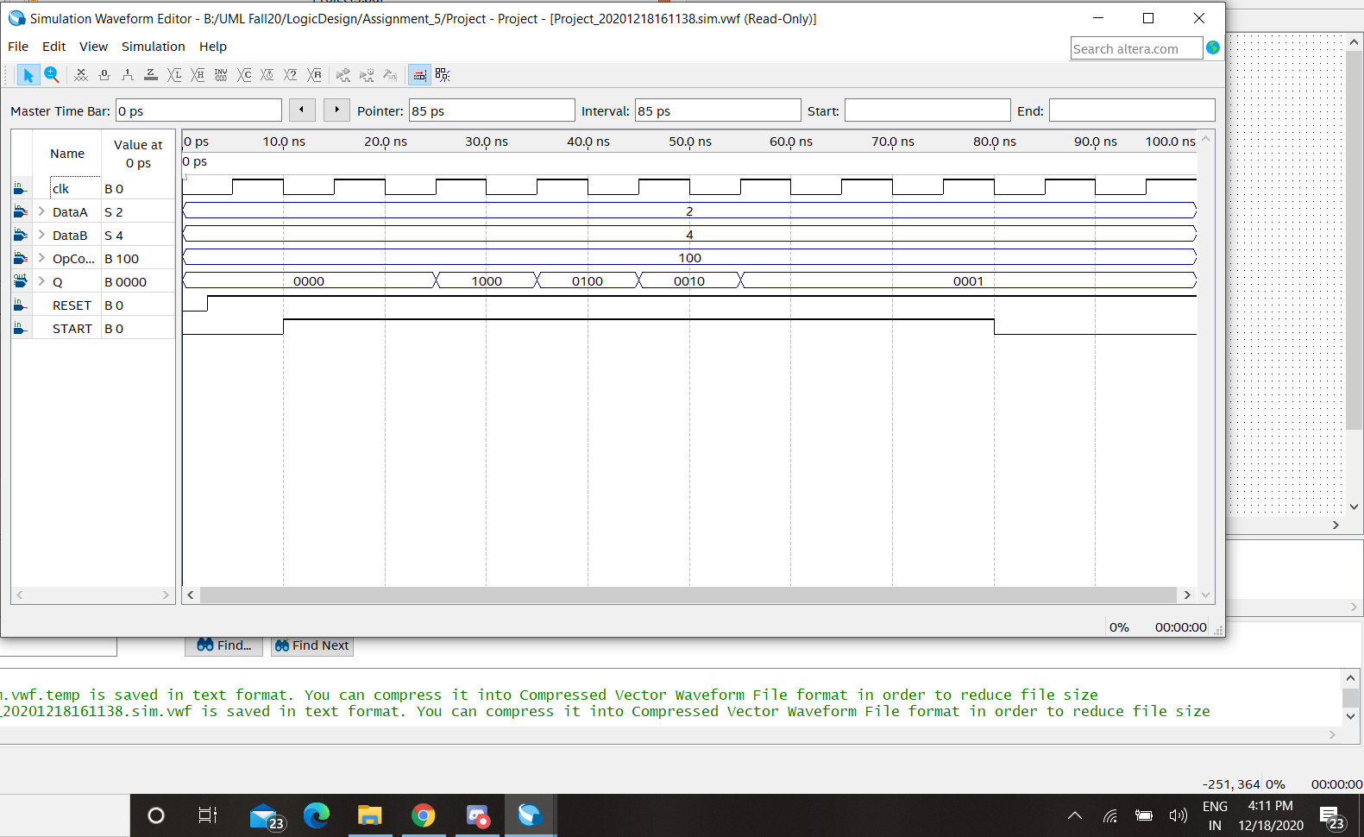

Simulation for OpCode 101, A|B:

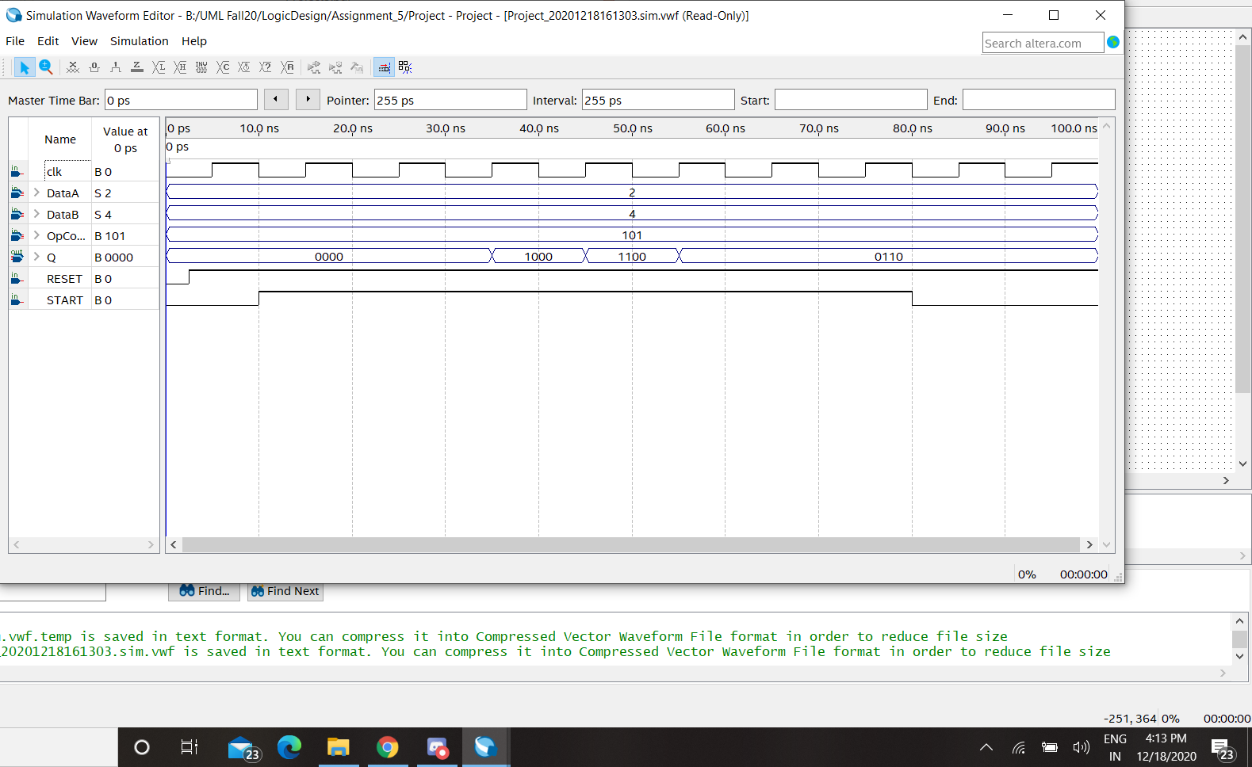

Simulation for OpCode 110, A&B:

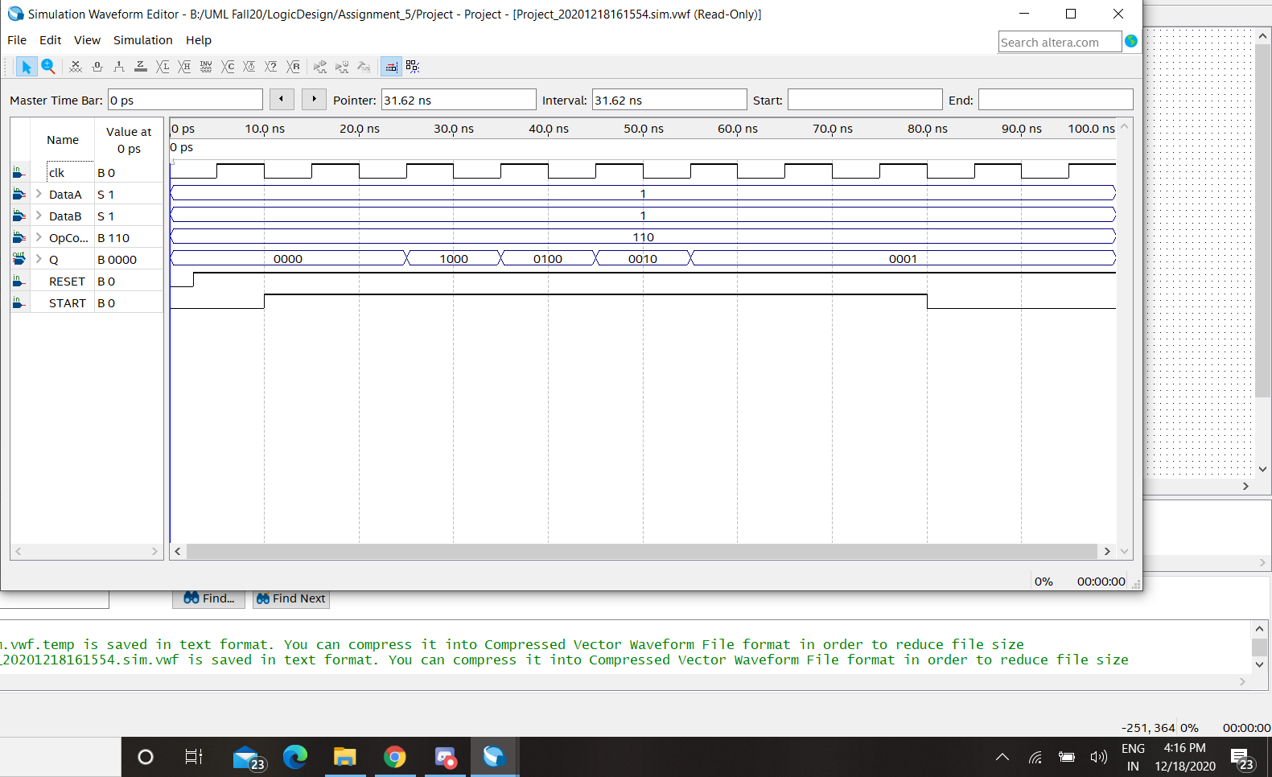

Simulation for OpCode 111, Negative A:

